Orsieres – Bourg St Pierre
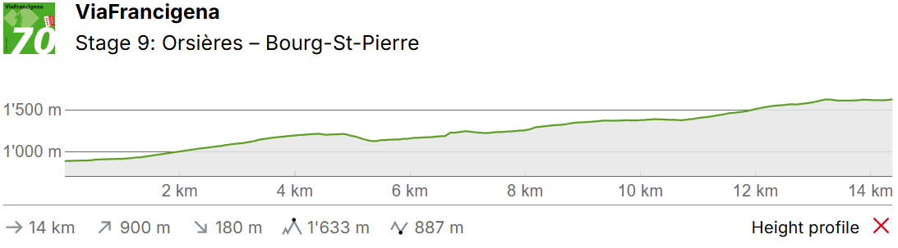

This stage first takes you along a forest trail to the left of the river. You then go to the right of the river along the historic path from Liddes to the small chapel of Notre-Dame-de-Lorette before reaching Bourg-St. Pierre.
The municipality of Orsières in Val Ferret has the largest forest area in Switzerland. The region is a paradise for bike and mountain tours. Various medicinal plants and herbs thrive here thanks to the balanced, dry climate and the location, flanked by mountains. These are mainly used for the production of cosmetic products.
Leaving the centre, the hiking trail branches off left into Val d'Entremont, and a gravel road takes you to Fontaine Dessous. This is where you cross the Dranse d'Entremont stream for the first time. Shortly after this is a steep zigzag path up to the Pont de la Tsi, where you cross the stream for the second time. A few minutes later, you traverse the stream again to arrive in Liddes. The community was created in 1308 when it split off from Orsières.
You have now been en route for about two and a half hours. Across fields and above the stream, the path then continues to climb towards Bourg-St. Pierre, the final village before the pass. This has determined the history of the village: numerous traditional buildings, the restored mill and the ruins of the Château du Bourg – known as “La Garette” - characterise the centre and the surrounding area. The region is also known for its rich flora and fauna. “La Linnaea” alpine garden contains a stunning cross-section of diverse alpine flora.

Bourg Saint Pierre accommodation

Gîte Maison Saint-Pierre
Basic pilgrim accomodation
30CHF PPPN
Rue de l'église 12, 1946, Bourg-St-Pierre, Switzerland
https://maisonstpierre.ch/
